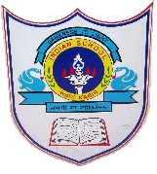
INDIAN SCHOOL AL WADI AL KABIR
HOLIDAY HOMEWORK

Class: 11th (CS) | Department: Computer Science | Date of submission:  12-01-2026
 | Topic: SOCIETAL IMPACTS | Note: To be uploaded in the google form link provided

Prepare a Power Point presentation with minimum 7 slides on the following points:

1. Digital Footprints
2. What is Intellectual property rights? How are they protected?
3. What are the different types of Cybercrimes?
4. What are the measures to be taken for cyber safety?
5. What is E-waste? What are the different ways of disposal of E-waste?

Convert the PPT to PDF format and upload in the google form link given below:

https://docs.google.com/forms/d/e/1FAIpQLSdQtyqV34fNiq6pl-9VS5EG9EBnDSe36eY5EHTjUybZG-Um7w/viewform?usp=header

